ER - Requeriments

Project: Sales Unificado

April, 2019

Table of content
Introduction 3
The solution 4
1.1 Layout 7
1.1.1 Main page: 7
1.1.2 Contract List: 7
1.1.3 Contract Form: 7
1.1.4 Appendix List: 8
1.1.5 Appendix Form List: 9
1.1.6 Invoice Order List: 10
1.1.7 Invoice Order Form: 10
1.2 Physical data model 11

Introduction

The application should serve as a fundamental element of the sales management of software of a license reselling company.
The sale of software and the management of renewal contracts and maintenance of software represents a fundamental part of the company's income, for this reason having a software that allows managing the process in an integral and unified way represents a great objective for the company.
The sale process is divided in different ways:

by type of licenses:
• Licenses in perpetuity or onPremise: in this type of sales the right of use is sold on one or more pieces of software for a specific use and under certain conditions that allow the buyer to use this piece of software permanently, together with this sale, a support service is provided (due to product errors) and a version upgrade and update service (making new versions of the software available). Many times this maintenance or support is mandatory during the first year and optional from the second year onwards. .
• Licenses by subscription or cloud: this type of licenses commercializes the right of use, with support and maintenance included in the value through the subscription to a service where the buyer can make use of the license and its support during the term of use of the license, once this period is over, you must renew or cease the use of the license.

By type of operation:
• Sale of licenses: this is the initial onPremise license sale process, where the software piece (s) is sold and the first year of use is maintained.
• Renewal: this process considers the renewal of the maintenance of the licenses sold in the previous step where the support service is sold and new versions of the software are made available. This type of process is associated with the sale of onPremise licenses.
• Subscription: the subscription is a mixture of these 2 previous processes since both services are within the value of the licenses and must be canceled to access to use the product and also the renewal and support of the software. This type of sales is associated with the type of sale by subscription or cloud.

By type of sale:
• Sales by contract: this type of sales formalizes the conditions of purchase and renewal or subscription through the signing of a contract that regulates the conditions of purchase and renewal, this formalizes the link with the customer.
• Spot or OC sales: this type of process allows the specific sale of the product or subscription in question and must review at the end of the acquisition period the desire to renew or maintain the subscription without establishing a formal contractual link beyond the acceptance of the software use agreement ("EULA")

It is for this reason that obtaining software that allows the administration of all this type of operations represents an important point in the structure of systems that the organization needs to manage.
- Through the following pages we will try to give clarity about the process that we must implement to give solution to the administration of the process through an integral software that allows to manage this type of solutions

The solution
The solutions have several master data structures and a few transactional objects to work with.

The master data are:

The ID fields in this tables or structures are identity fields, they are self-generated in the database.
For each table in the list below we need to generate a CRUD to create, edit, modify or delete the values in the entity.

- CLIENTE (CUSTOMER)
Customer information
  - ID_CLIENTE
  - ID_PAIS
  - ID_INDUSTRIA
  - ID_GRUPO_CLIENTE
  - FECHA_ALTA
  - NUM_CLIENTE_PROV
  - NUM_CLIENTE_PLNG
  - COMENTARIOS
  - RAZON_SOCIAL
  - CLAVE_FISCAL

- CONTACTO (CONTACT)
Contact information for the Customer.
  - ID_CONTACTO
  - ID_CLIENTE
  - NOMBRE_CONTACTO
  - MAIL
  - TELEFONO
  - DOMICILIO
  - CP
  - CIUDAD
  - PROVINCIA
  - PAIS
  - PRIORIDAD

- ESTADO (STATUS)
Status of the appendix, contract, or invoice: the status is: valid, suspended, terminated
  - ID_ESTADO
  - COD_ESTADO
  - DES_ESTADO

- GRUPO_CLIENTE (CUSTOMER GROUP)
The table has information about the customer group to address holdings.
  - ID_CLIENTE
  - COD_GRUPO_CLIENTE
  - GRUPO

- INDUSTRIA (INDUSTRY)
They have the industry of the customer.
  - ID_INDUSTRIA
  - COD_INDUSTRIA
  - DES_INDUSTRIA

- PRODUCTO (PRODUCT)
This is the product information, has the name of the licence or subscription sold.
  - ID_PRODUCTO
  - ID_TIPO_PRODUCTO
  - COD_PRODUCTO
  - DES_PRODUCTO
  - METRICA
  - BLOQUES
  - MINIMO

- PROVEEDOR (VENDOR)
This is the vendor information table.
  - ID_PROVEEDOR
  - ID_UNIDAD_NEGOCIO
  - COD_PROVEEDOR
  - DES_PROVEEDOR
  - CLAVE_FISCAL
  - RAZON_SOCIAL
  - NOMBRE_FANTASIA
  - DIRECCION
  - PAIS

- REGION
This table has region, the value can be: Argentina, Chile, Peru, Colombia, Caribe, CAM
  - ID_REGION
  - COD_REGION
  - DES_REGION

- SOCIEDAD (COMPANY)
This table has information about the company who sold the software licence
  - ID_SOCIEDAD
  - RAZON_SOCIAL
  - CLAVE_FISCAL

- TIPO_CONTRATO (CONTRACT TYPE)
The table contains the contract type: Perpetual, subscription, one time.
  - ID_TIPO_CONTRATO
  - COD_TIPO_CONTRATO
  - DES__TIPO_CONTRATO

- TIPO_POSICION (POSITION TYPE)
This table has the type of the position in the LINE ITEMS tables, the possible values are: Mantenimiento (renewals), FULL (Sales)
  - ID_TIPO_POSICION
  - COD_TIPO_POSICION
  - DES_TIPO_POSICION

- TIPO_PRODUCTO (PRODUCT TYPE)
This table has the product types: Cloud, onPrem.
  - ID_TIPO_PRODUCTO
  - COD_TIPO_PRODUCTO
  - DES_TIPO_PRODUCTO

- UNIDAD_NEGOCIO (BUSINESS UNIT)
This tables has the business unit information the value are SAP, TABLEAU, MICROSOFT
  - ID_UNIDAD_NEGOCIO
  - COD_UNIDAD_NEGOCIO
  - DES_UNIDAD_NEGOCIO

- VENDEDOR (SALES PERSON)
  - ID_VENDEDOR
  - COD_VENDEDOR
  - DES_VENDEDOR

The transactional objects are:

CONTRATO_CABECERA (CONTRACT): This entity has all the information about the contract.

APENDIX this entity has information about the appendix, theare are two tables the first one has the general information about the appendix (similar to a contract) and the second part has the line items, the products purchased by the cliente and the cost of the software from the vendor side.
- APENDICE_CABECERA (APENDIX HEADER)
- DETALLE_APENDICE (APENDIX LINE ITEM)

INVOICE ORDER:
These are the tables for the invoice order, it has 4 main tables, PO is similar to the Apendix header, the PO_DETALLE similar to APENDIX LINE ITEM and CLIENT INVOICE and VENDOR INVOICE are part payments due by the client o the vendor respectively
PO (INVOICE ORDER HEADER)
PO_DETALLE (INVOICE ORDER LINE ITEM)
CUOTA_PO (CUSTOMER INVOICE)
FACTURA_PROVEEDOR (VENDOR_INVOICE

Layout

Main page:

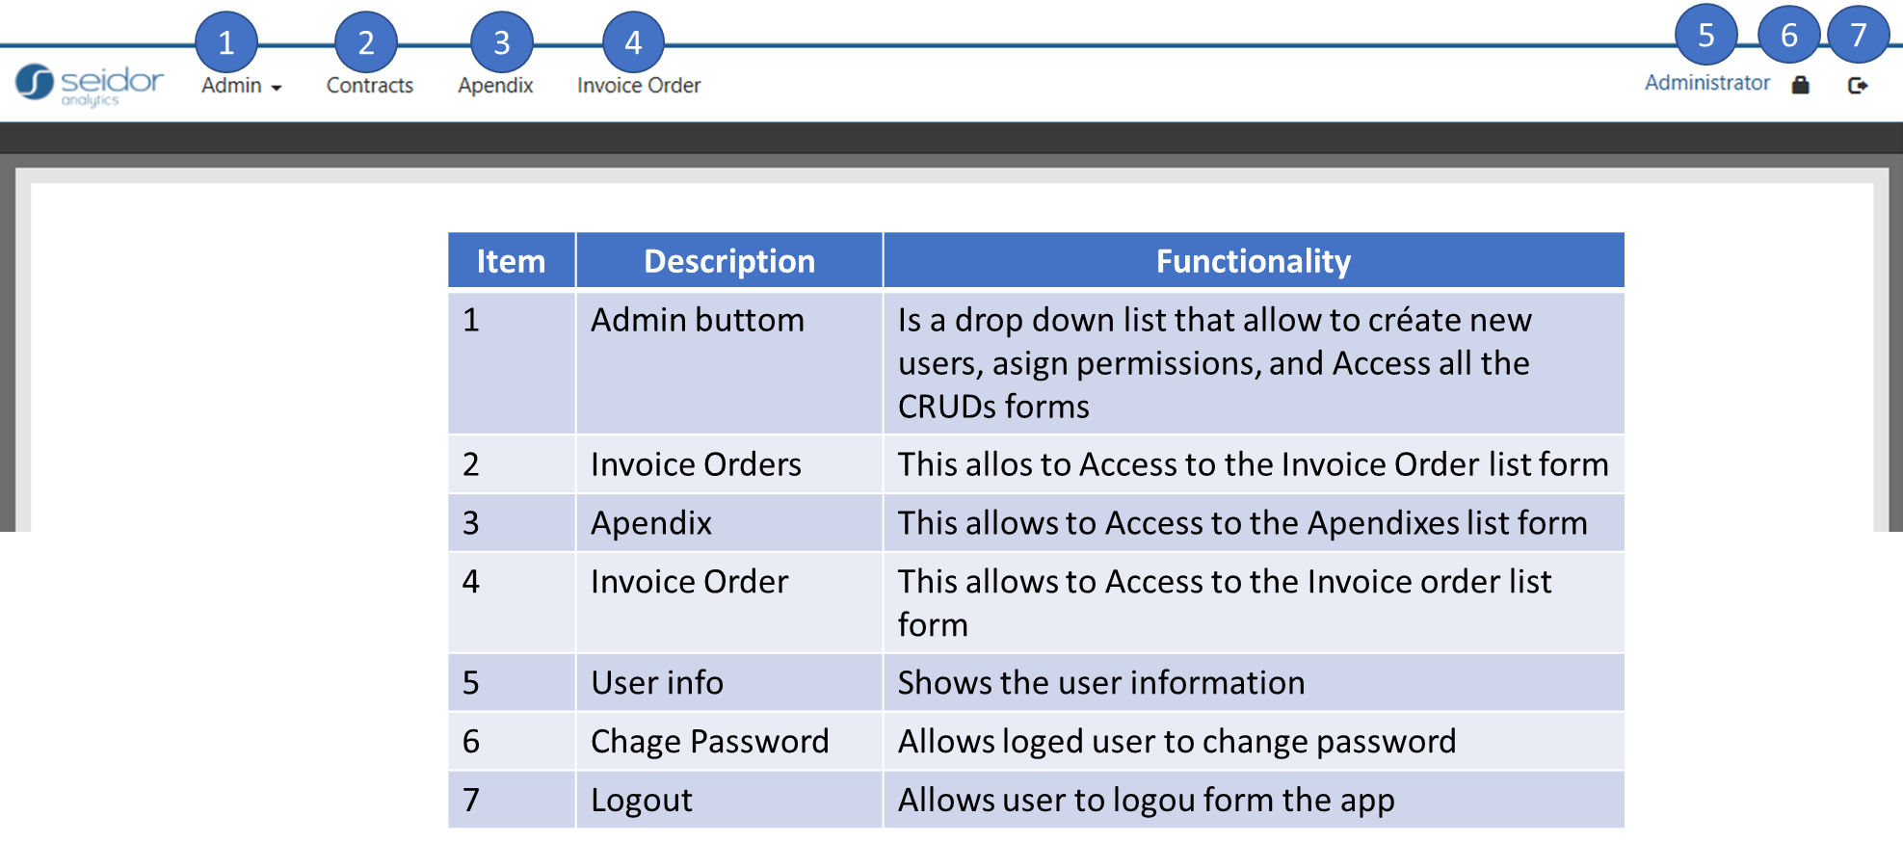

Contract List:
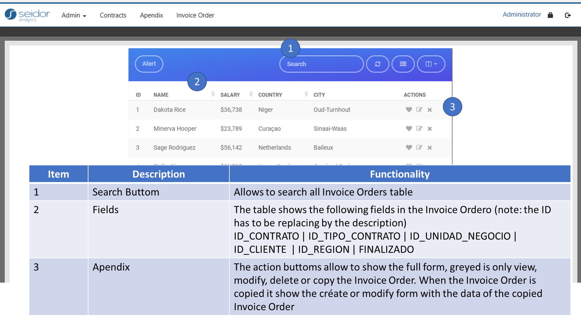

Contract Form:

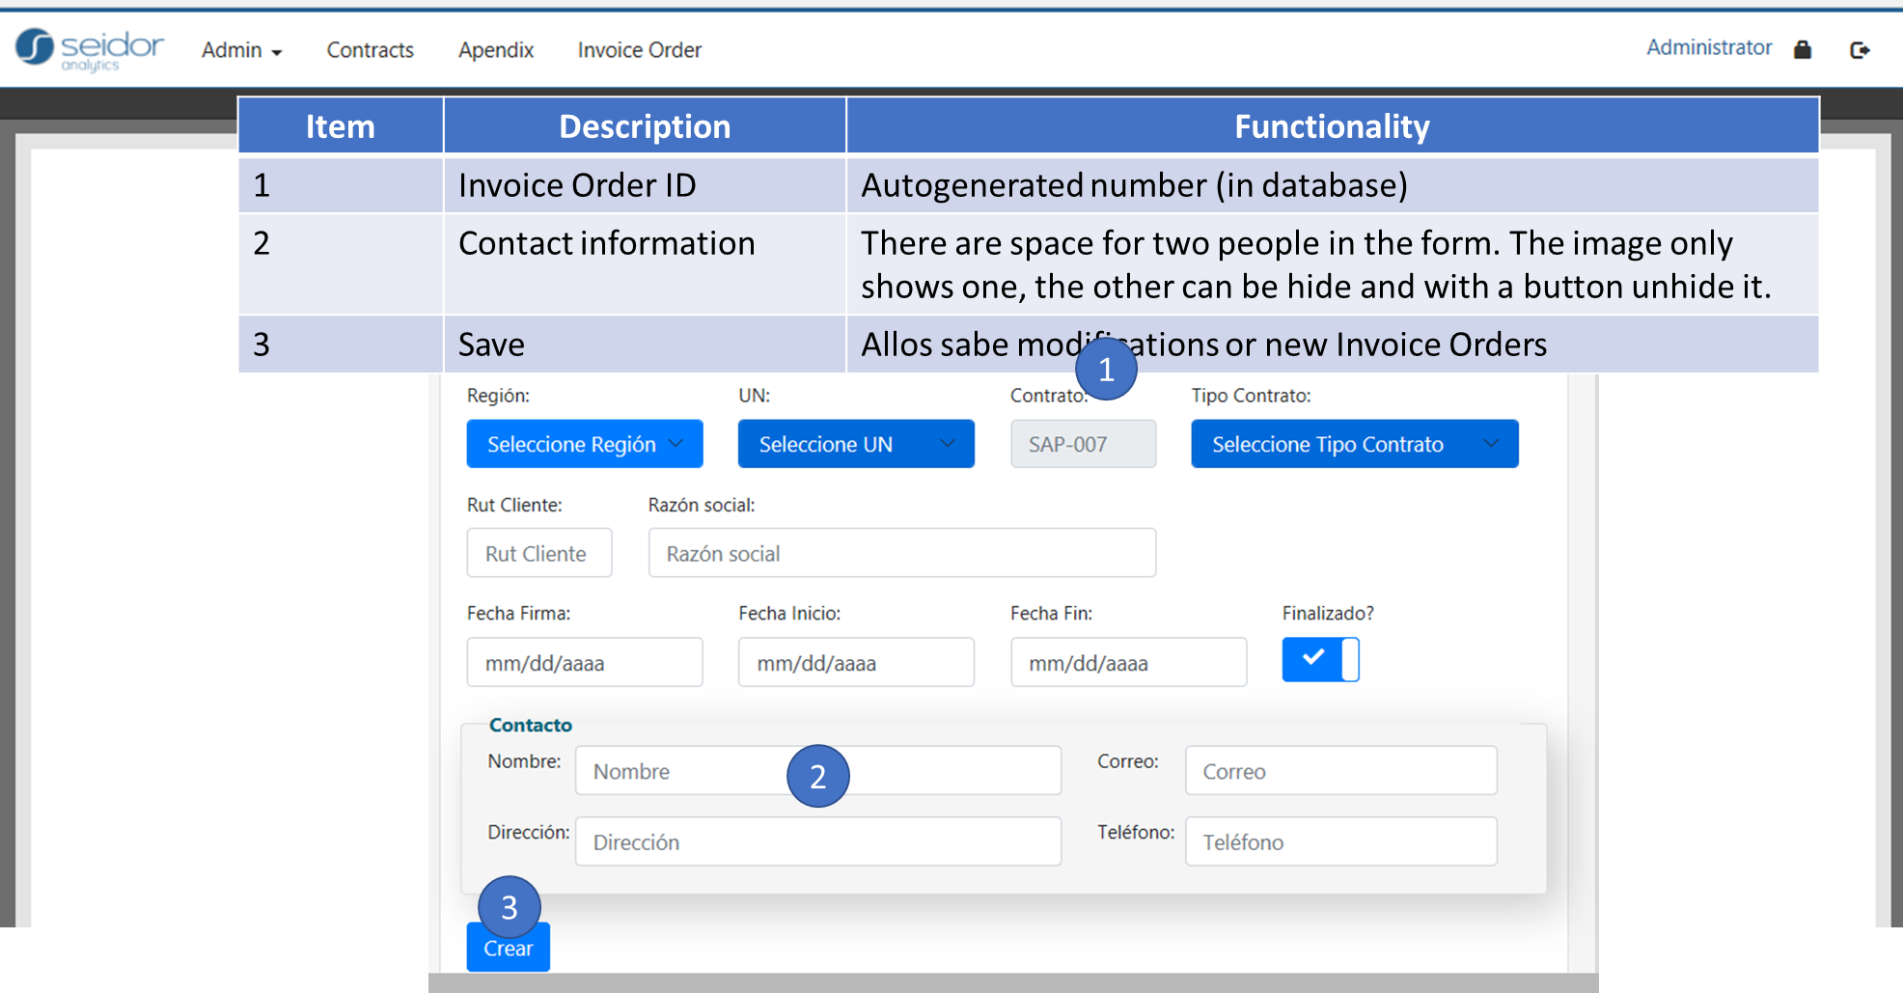

Appendix List:

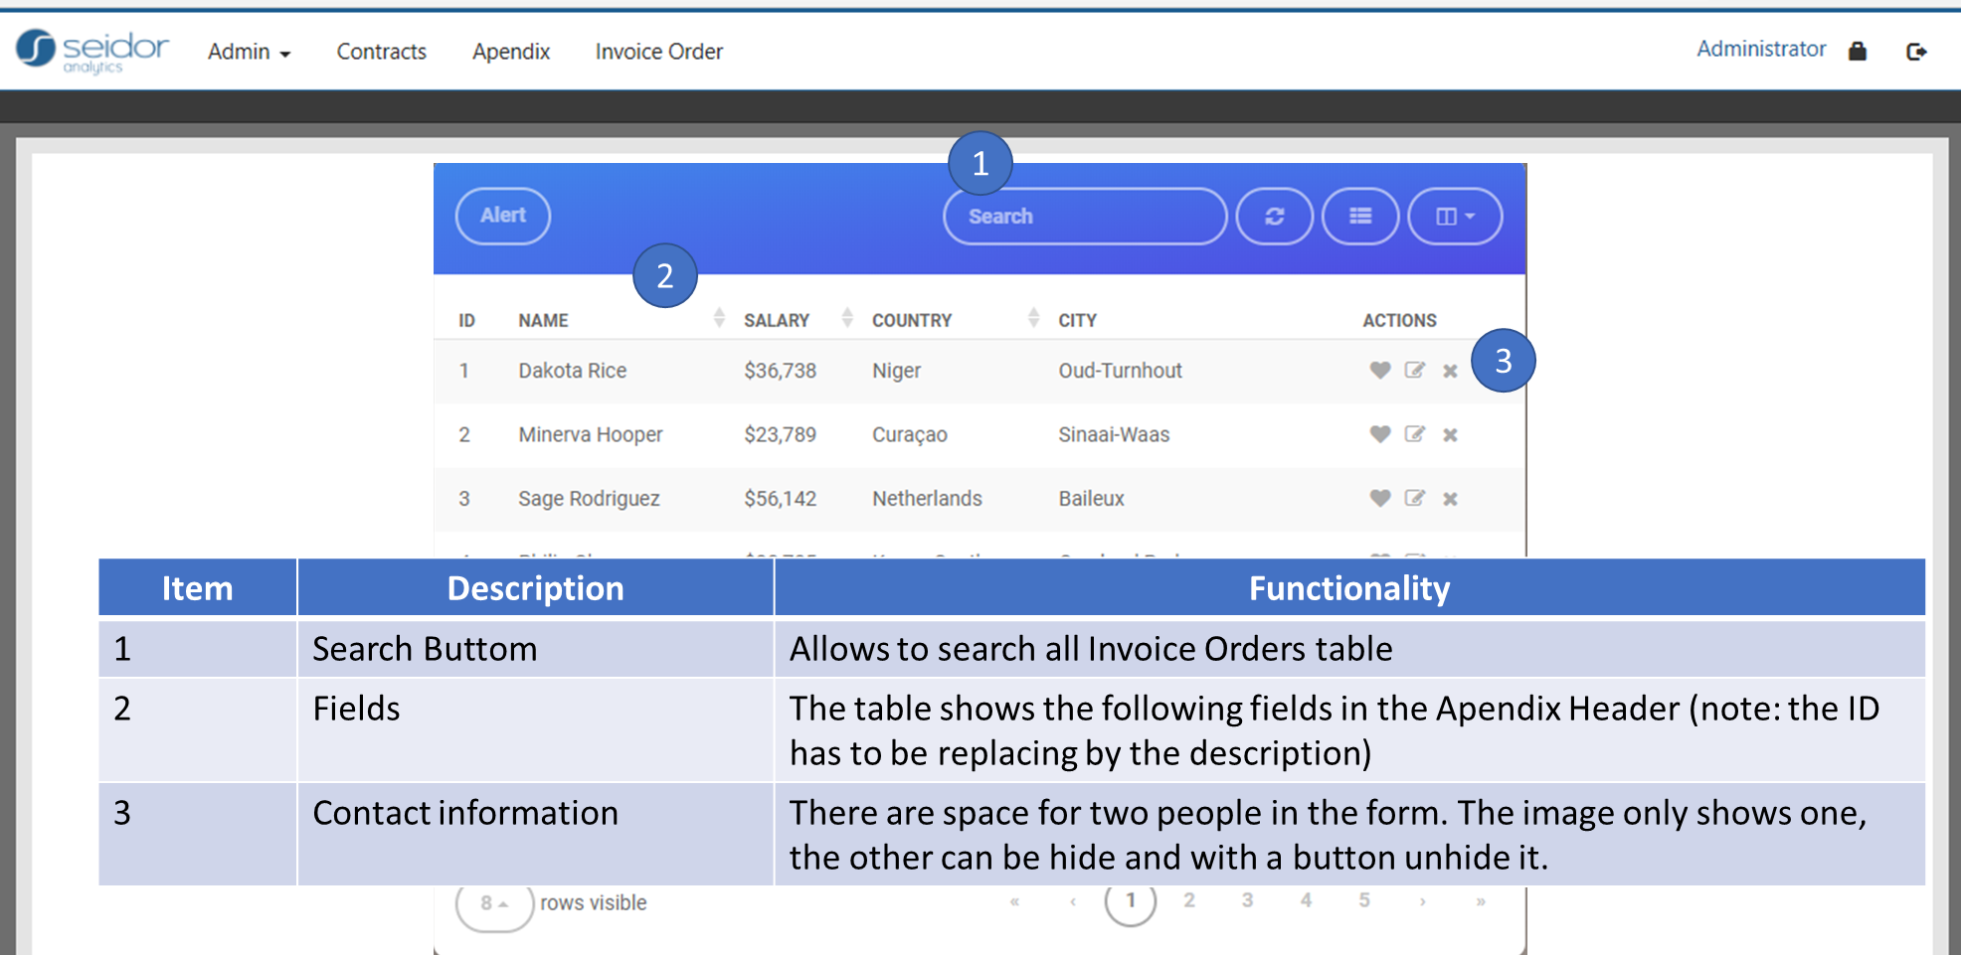
Note: the list of fields will be defined later.

Appendix Form List:
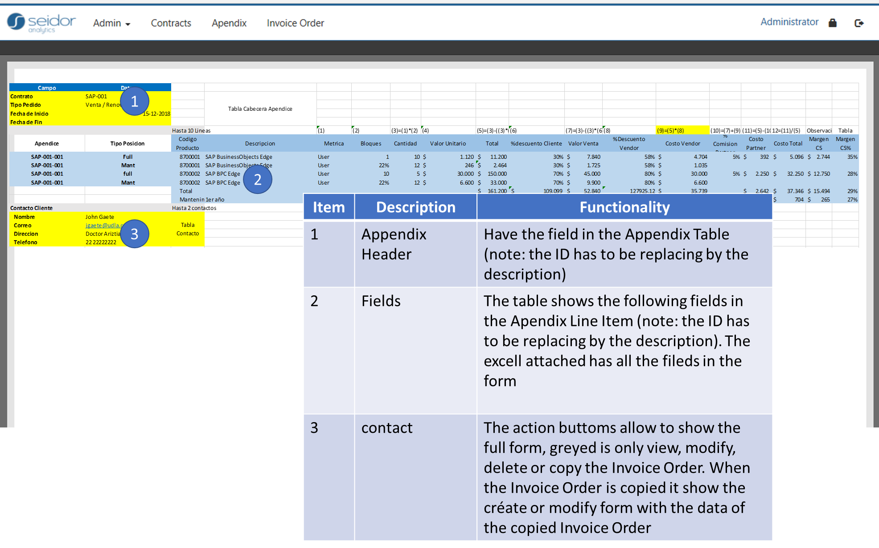

Note: The lines in the form are variable, depends in user selection, the user can add all the lines that he wants in the appendix line item.

Invoice Order List:

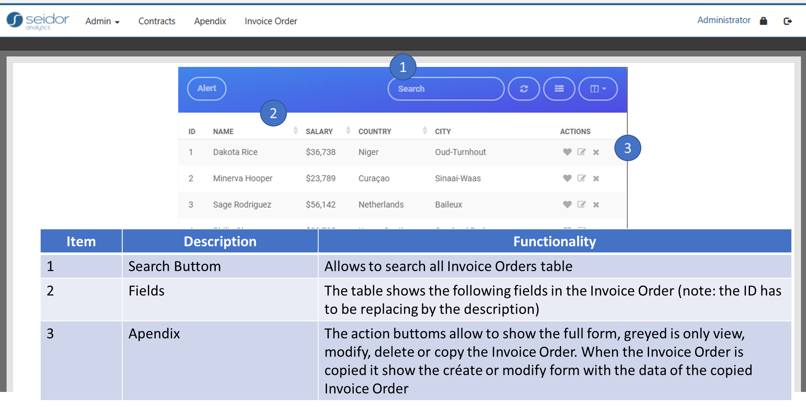
Note: the list of fields will be defined later.

Invoice Order Form:
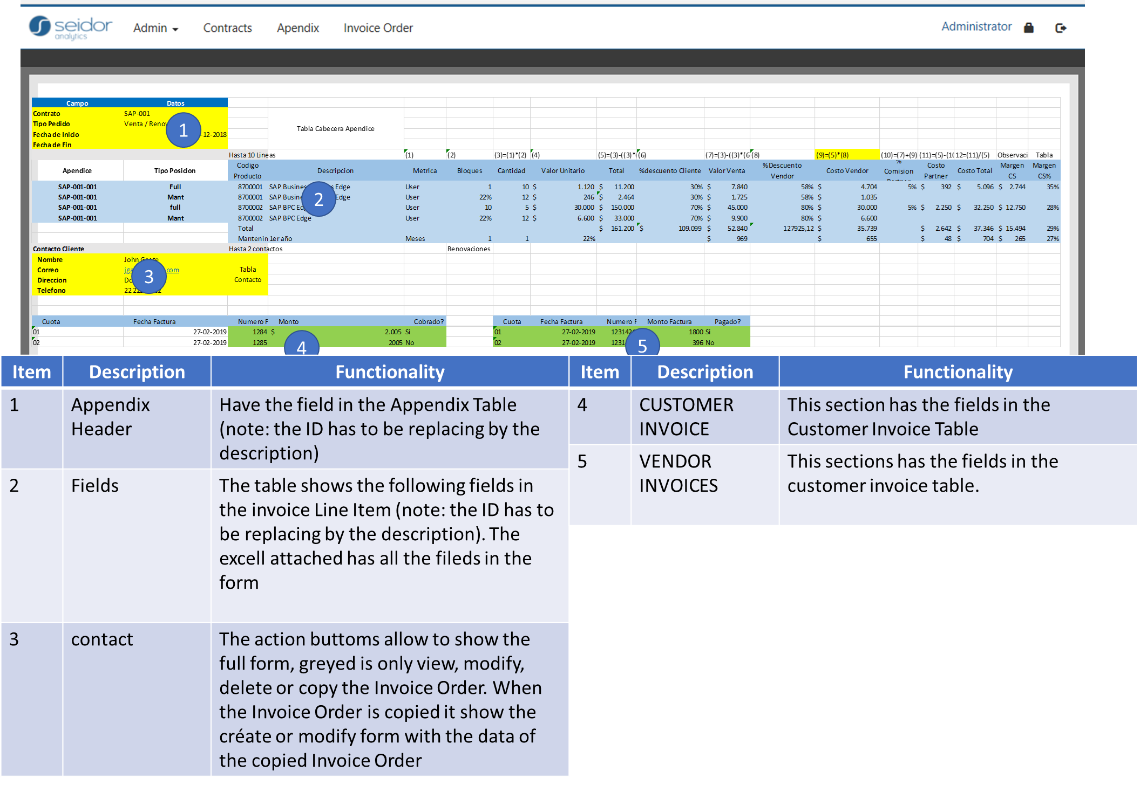
Note: The lines in the form are variable, depends in user selection, the user can select or pick wich lines in the appendixes in the main contract are used in this invoice form. The user can add more lines not in the mail contrac appendixes, those lines must be added manually.

Physical data model

